THE
UNDERWORLD
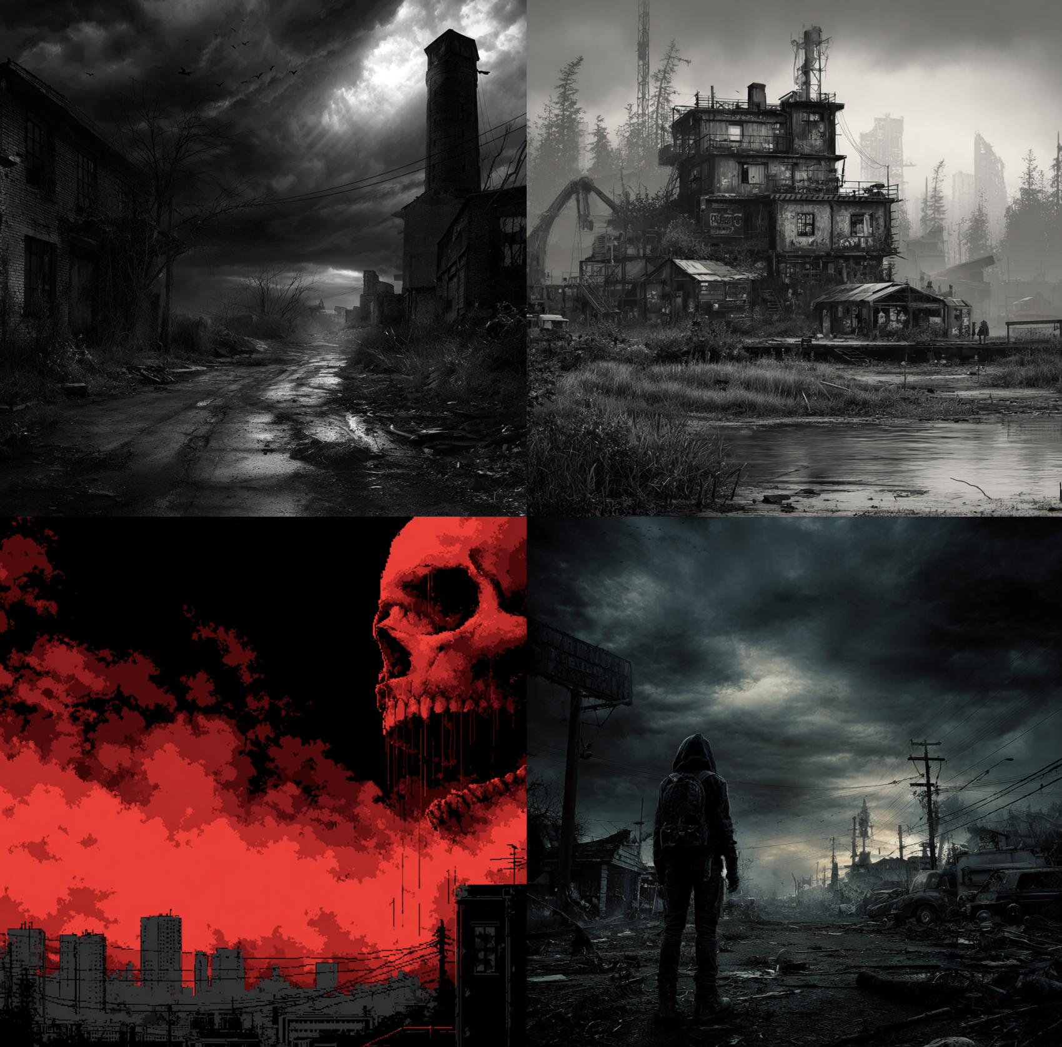
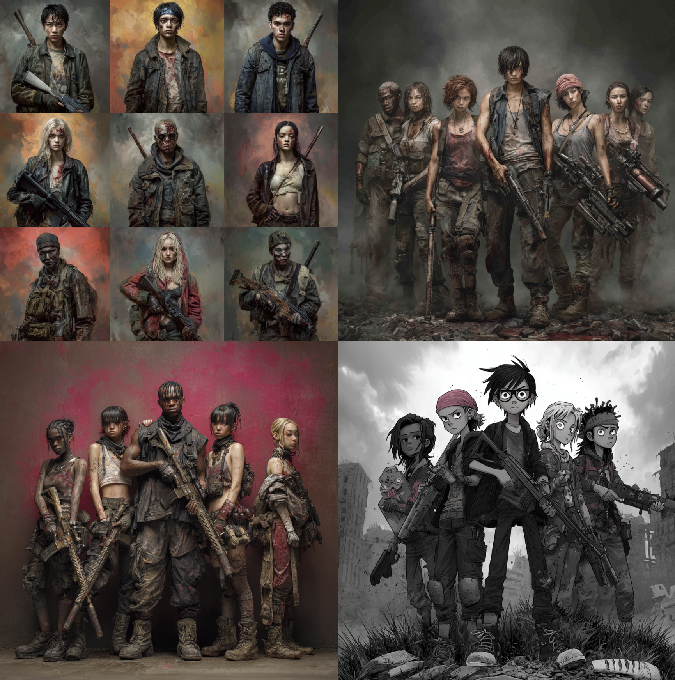
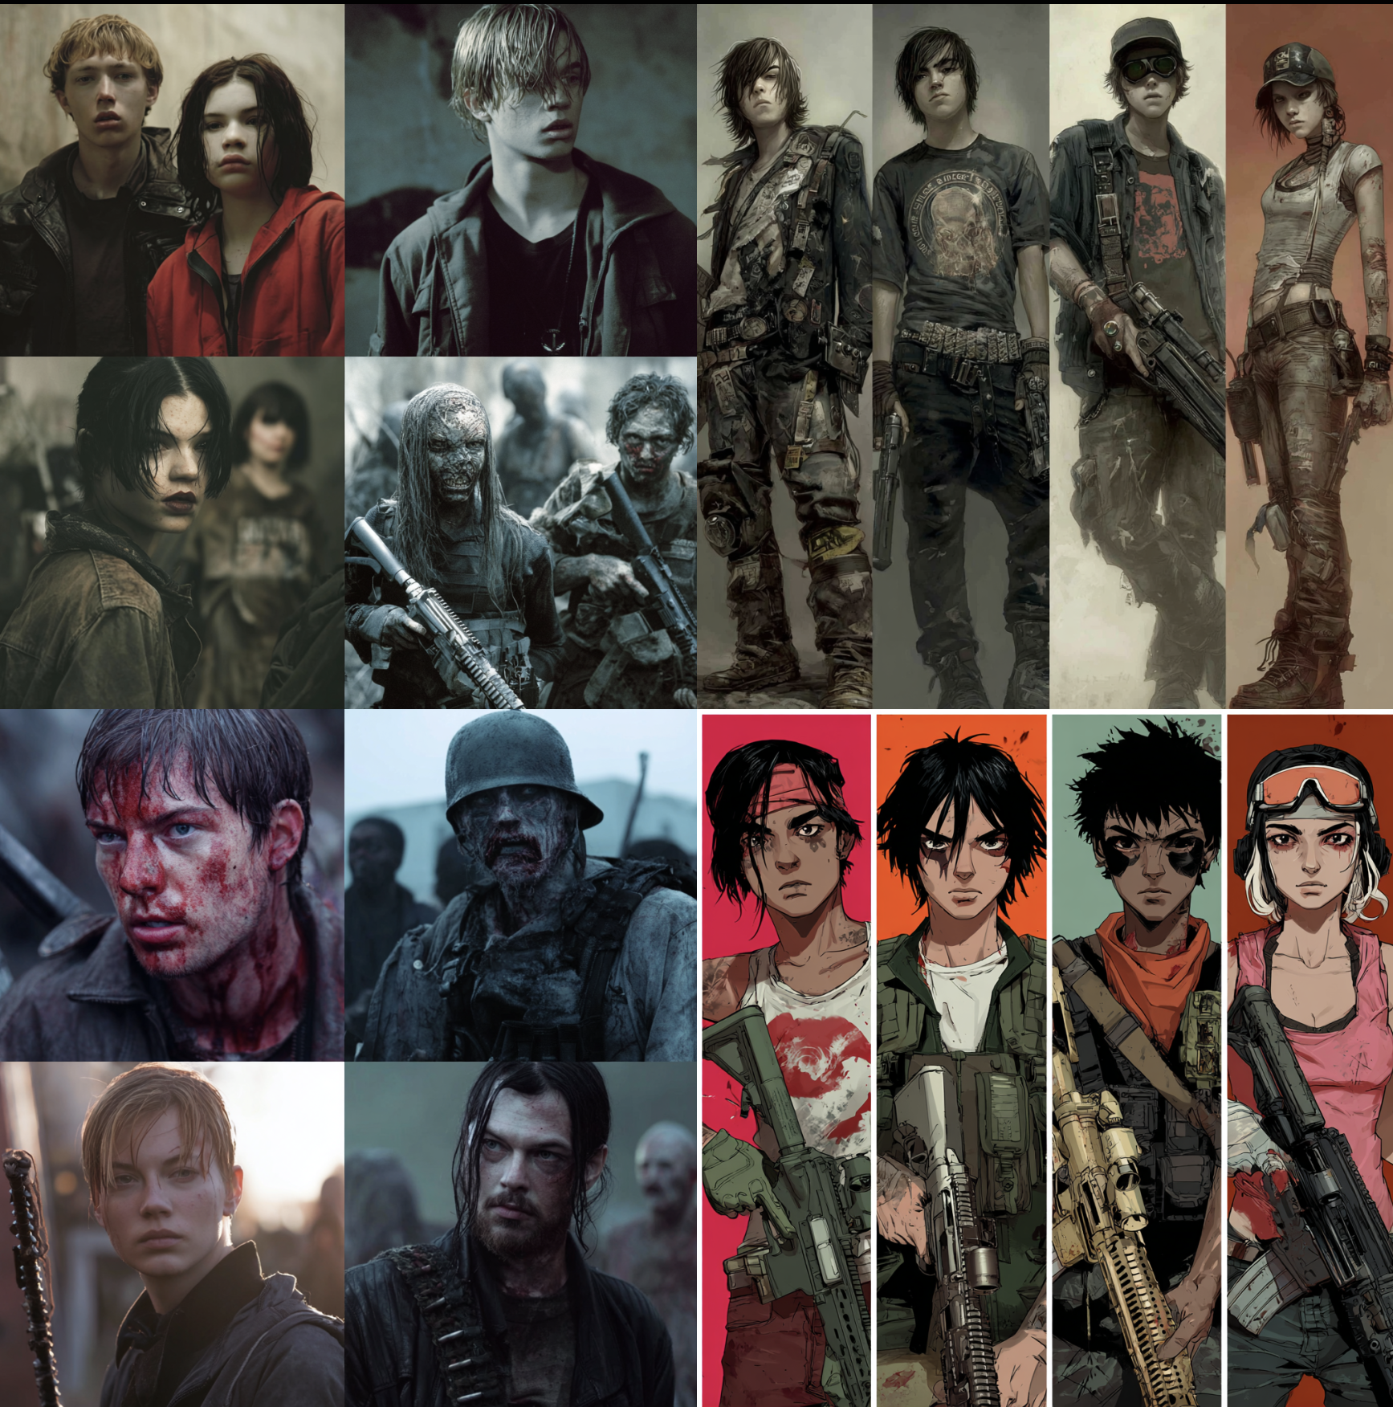

The Legend of Sket (SKAY)
Sket, once known as SKAY, was a musician — a sold-out rockstar from Million Bay’s west side.
He had the stage. The lights. The world.
But when the outbreak hit, the crowd changed — the fans became flesh-eaters, and the music turned to sirens.
Sket didn’t hide. He led.
He gathered a band of survivors — old roadies, fans, strangers, and believers — and guided them into the sewers beneath Million Bay. He told them they weren’t running from death…
They were building something beneath it.

Birth of the Underworld
Down there, in the dripping tunnels and cold brick chambers, Sket’s people built fires and carved words into the walls. “THE UNDERWORLD.”
That was his vision — a new civilization, one that could live unseen, rebuild from the rot, and rise again.
He was joined by those who would become his first council:
King Erroll, Queen Agatha, Tabitha, Steven, Deryck, Claudia, and Stone Morgan — a circle bound not by blood, but by belief.
Together they traveled east, through the maze of tunnels, toward Sket’s family-owned compound — a place of rumored warmth and safety. Along the way, the group learned to use music and light as weapons, drawing Greapers into sound traps while mapping the sewers like a kingdom under construction.

The Last Song
But when a swarm of Greapers fell through the tunnels one night, Sket made a choice.
He turned back.
He told Nathaniel and Agatha to take his crown and finish the build, calling it the NU Kingdom — the New Underworld Kingdom.
Then he picked up his old guitar, now wired to batteries and sharpened metal, and led the monsters away from his people — down a long tunnel that reeked of gasoline and decay.
He fought until the lights went out.
By the time he reached the surface in the heart of Million State, he’d already been bitten.
Witnesses say they saw him laughing, swinging that guitar like thunder before he fell — dying on his feet, smiling through the blood.

The Kingdom Lives
Nathaniel and Queen Agatha kept his promise. They cleansed the sewers, fortified the compound, and spread east — transforming the dark into the NU Kingdom.
The people wore black robes, painted symbols on their faces, and turned old subway stations into temples. Rituals replaced prayer. Music replaced sermons.
Every chord, every strike of a drum, echoed Sket’s last song — a rhythm of defiance.
The Underworld ZET became more than survivors.
They became keepers of memory.
Their alliance with the Renegades gave them supplies, explosives, and information. Their faith in the fallen musician gave them strength. And when Sunny Jean found Sket’s story years later — and realized Sket had once been his classmate — it wasn’t just history. It was destiny.
Sket’s thunder — the raw, electric sound he left behind — became a gift to Sunny.
A symbol that the soul of the old world still burns beneath the new one.

The East Side Now
The east side glows dimly at night. Black smoke rises from the vents, carrying chants that sound like hymns and screams all at once.
Strangers whisper that if you walk far enough east, you’ll hear a guitar echoing from below — a sound too human to be the dead.
That’s the Underworld ZET.
A nation born from the dark.
A kingdom that worships sound, spirit, and survival.
A place where Sket still plays, somewhere deep beneath the bones of Million State.

