RENEGADE
TERRITORY
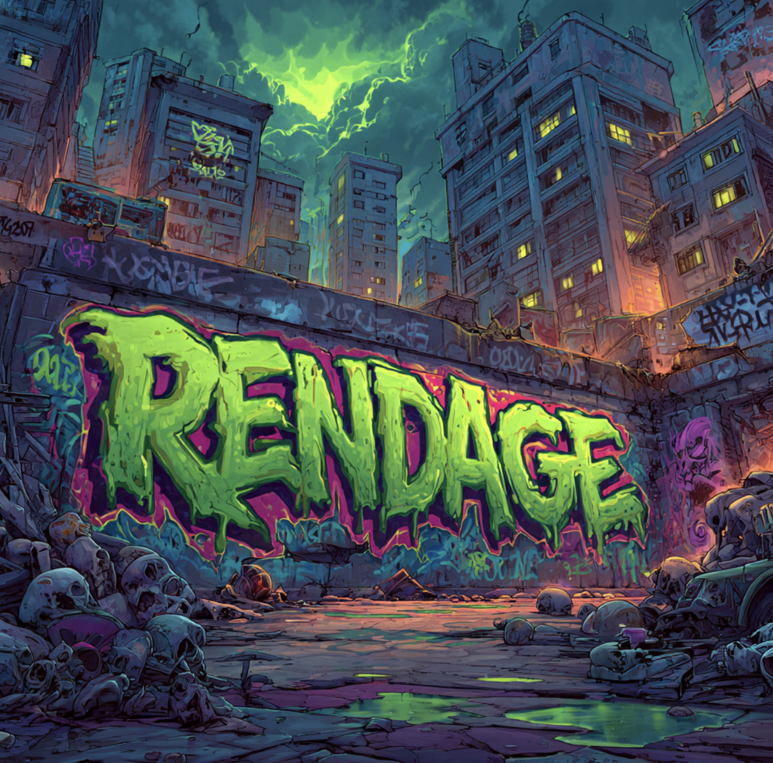
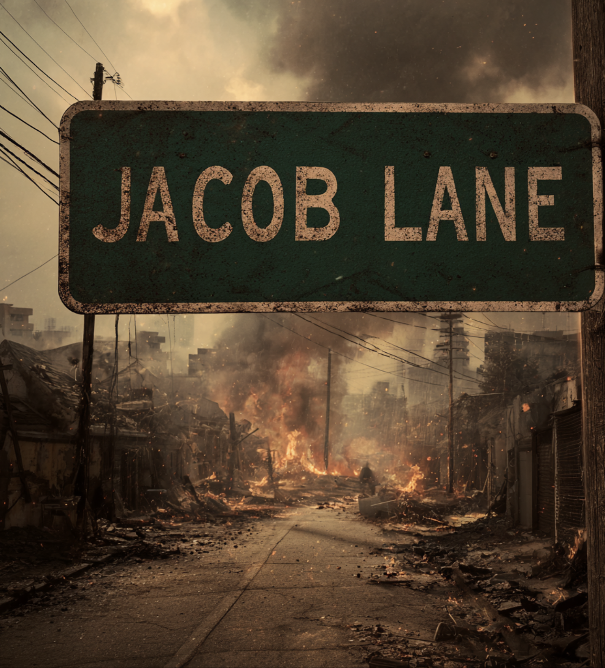
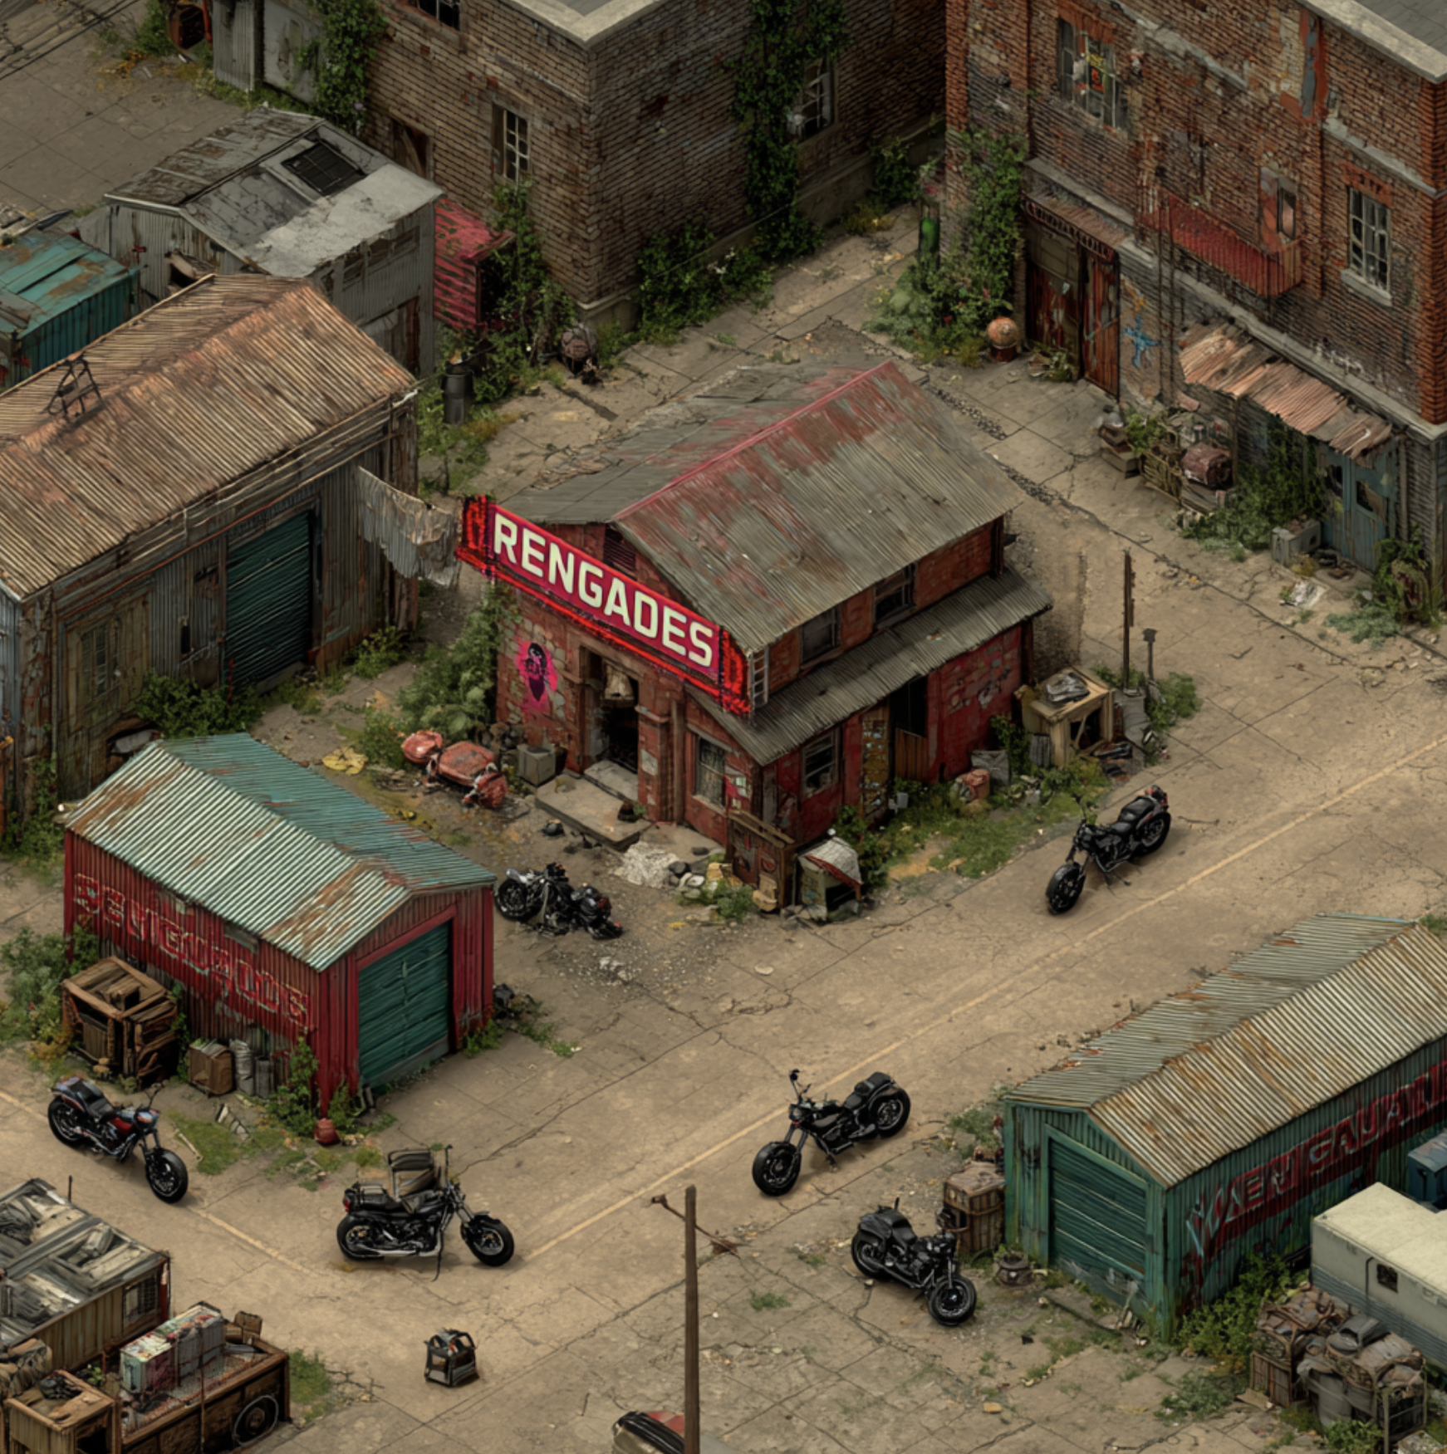
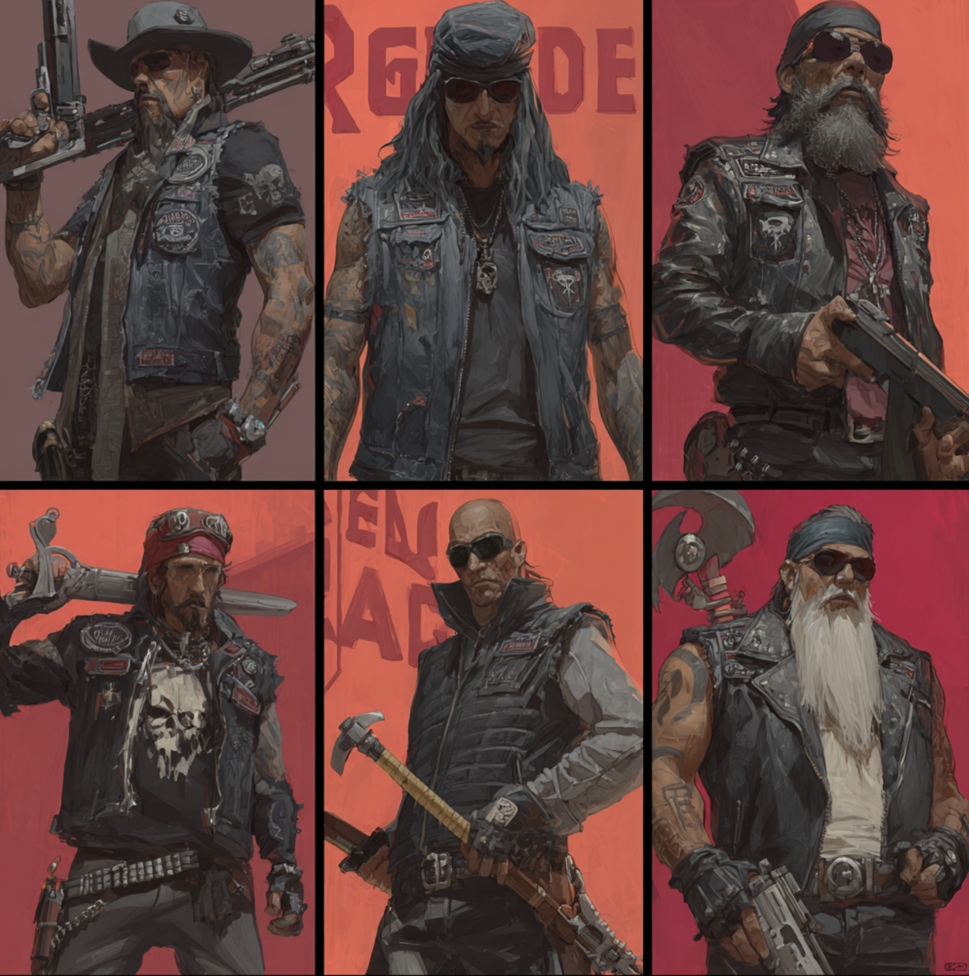

The West Side — Renegade Territory
Out past the broken skyline of Million Bay, where the ocean wind still carries the smell of burnt oil and bad decisions, lies the Renegade Territory — the west side of Million State. It’s a wasteland of cracked freeways, rusted motorcycles, and ghost lights flickering from old project buildings that should’ve fallen years ago. But they stand — because the Renegades stand.

The Rise of the Renegades
Before the Fall, the Renegades were a street race gang tearing through Million Bay’s industrial zones.
Their president, Joseph “Jay” Ballad, was a Puerto Rican-Black kid raised between hunger and horsepower. His life was asphalt, adrenaline, and outlaw brotherhood. To the city, he was a menace. To his people, he was freedom on two wheels.
They ran night races down Hillifer Boulevard, bet pink slips at South Mill, and slept in garages that reeked of gasoline and sin.
But when the world started to rot — when the sirens turned to screams and the dead started walking — Jay did what no politician or preacher could.
He took control.

The Compound
Jay led his crew to a forgotten industrial compound at the edge of Million Bay. Behind concrete walls and rusted gates, they built a fortress out of scrap metal, fire, and loyalty. The place became infamous — half refuge, half hellhouse.
They welded bikes into barricades, hung license plates as war trophies, and turned a two-story warehouse into their throne room. There was a bar that never closed, a brothel that never slept, and a basement filled with bomb-makers and scavengers.
It was here Jay met Tillifer — known to most as Tilly, a woman as dangerous as she was beautiful — and Josie, whose laugh could cut through the static of apocalypse. Together, they made the compound a kingdom of pleasure and danger.
Smoke, blood, whiskey, and sex — the air was thick with all four.
If you were Renegade, you were untouchable.
If you weren’t, you didn’t come back.

The Fall of Jay Ballad
In 2022, the peace shattered. The Nomen, an outbreak cult from the east, raided the compound. They believed the Renegades’ explosives were the key to cleansing the city — fire for fire.
Jay fought like a lion but was gunned down in the chaos, dying on the same asphalt he once ruled. His brothers burned their cuts that night — not out of shame, but war.
With Jay gone, Tilly rose from the ashes. Under her, the Renegades rebuilt — sharper, meaner, and twice as brutal.

The Storming
By early 2023, the compound fell again — this time not to men, but to monsters. Greapers tore through the west like a flood of teeth and disease.
Bodies piled. Walls collapsed. The bar turned into a burning tomb.
Tilly barely escaped with a handful of survivors. The Renegades abandoned their fortress and seized the old Nomen Projects, a block of cracked concrete housing units by the coast. They renamed it the Renegade Projects, marking every door with their insignia — a red skull on black metal.
From there, the gang expanded, claiming the entire western front as their own. Million Bay became their bloodline, their holy ground. They control the ports, the tunnels, the old radio towers. No one moves in or out without paying tribute or losing a limb.

The West Today
The west side still hums with outlaw energy. The streets echo with roaring bikes, and the smell of smoke never leaves the air. Between the broken palms and shattered streetlights, you can see it — the symbol of the Renegades burned into brick and bone.
People say the west has no law. That’s a lie.
It has one law: Ride or die.
Stay away from the west side.
The Renegades are watching.

