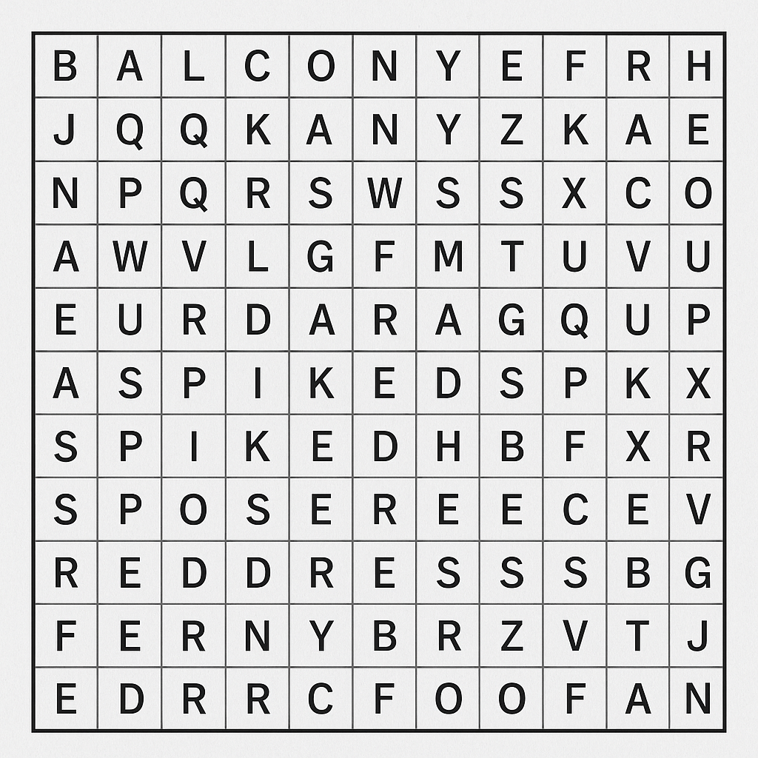

Words: balcony | alcohol | pill | spiked | red dress | ring

