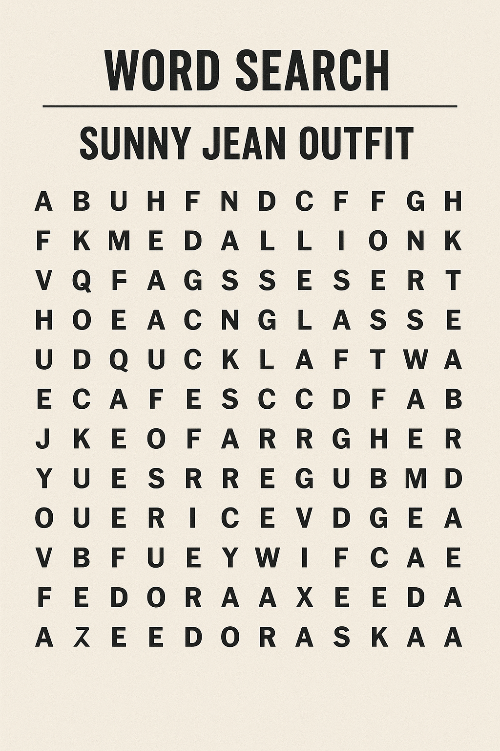
Words: fedora | medallion | axe | sunglasses | tattoo

