NOMEN
LAND
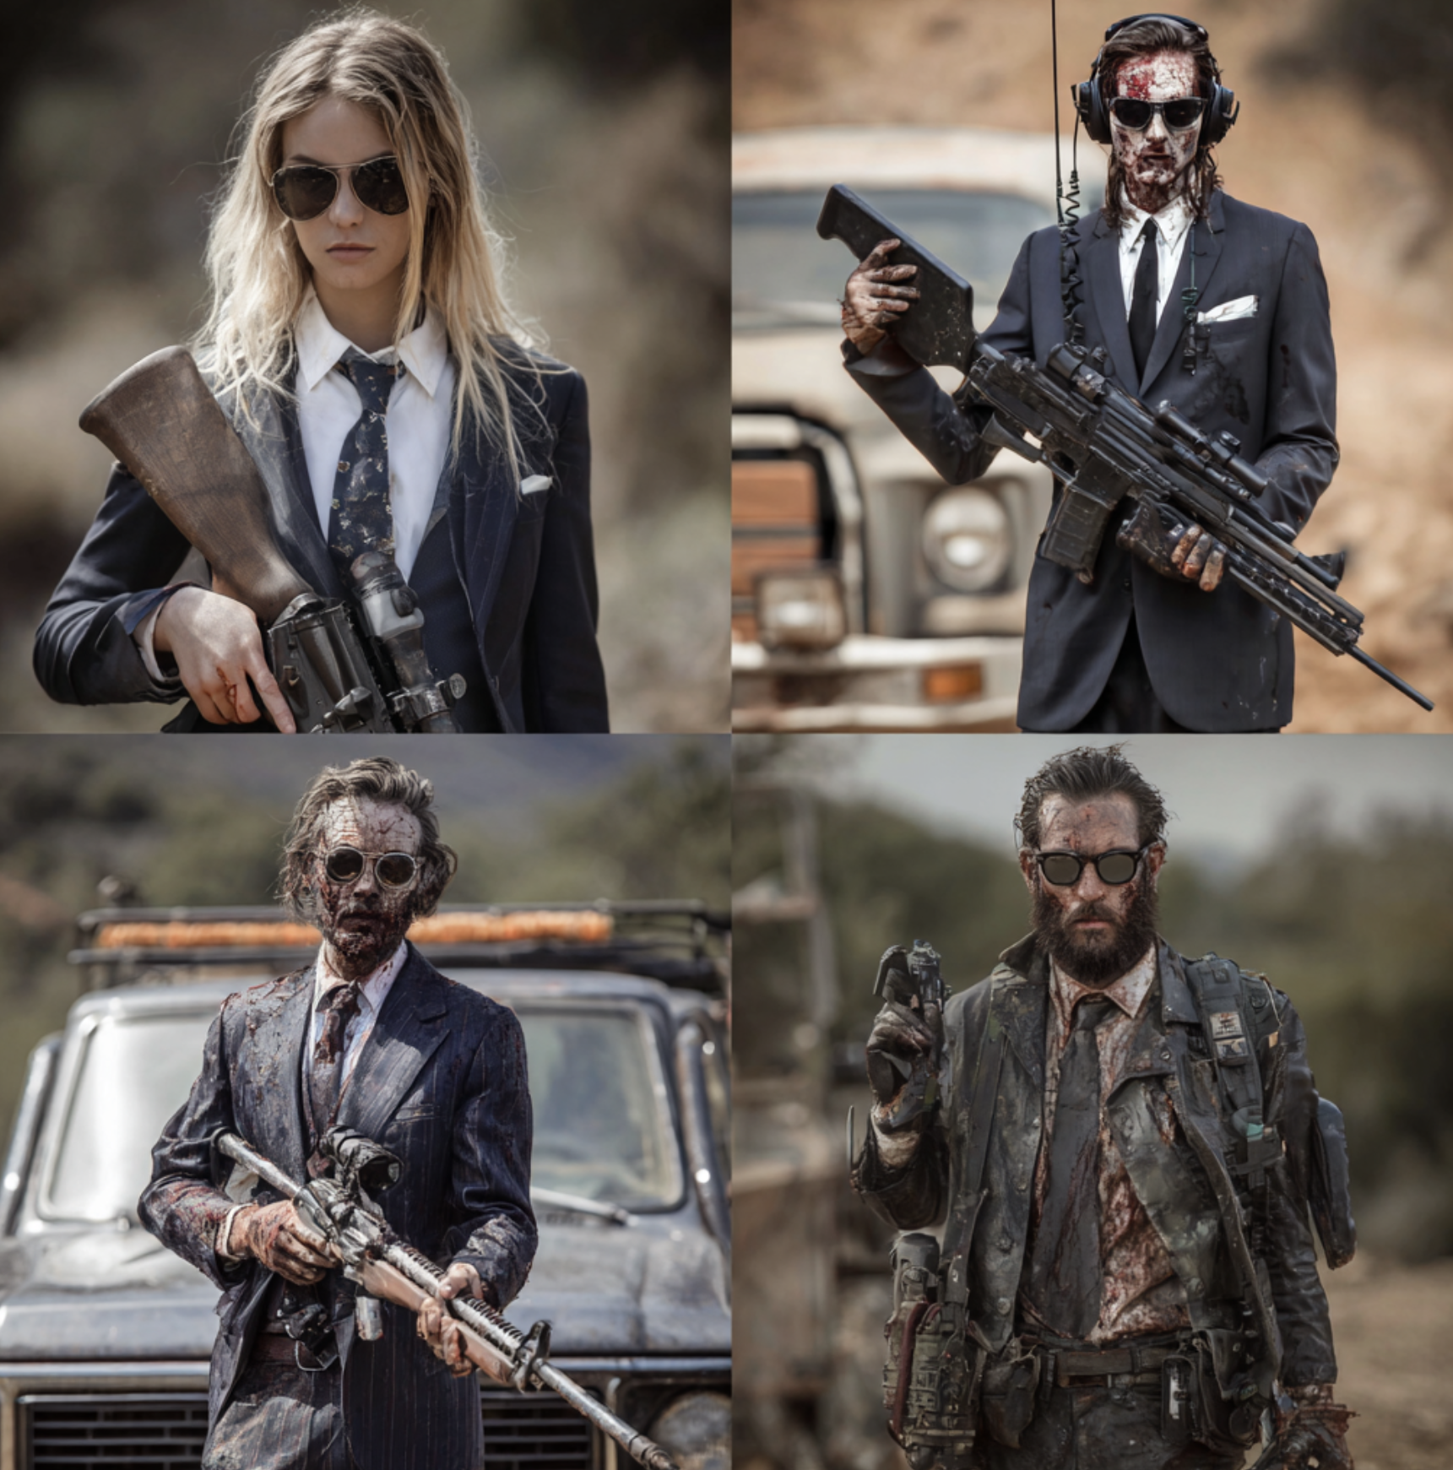
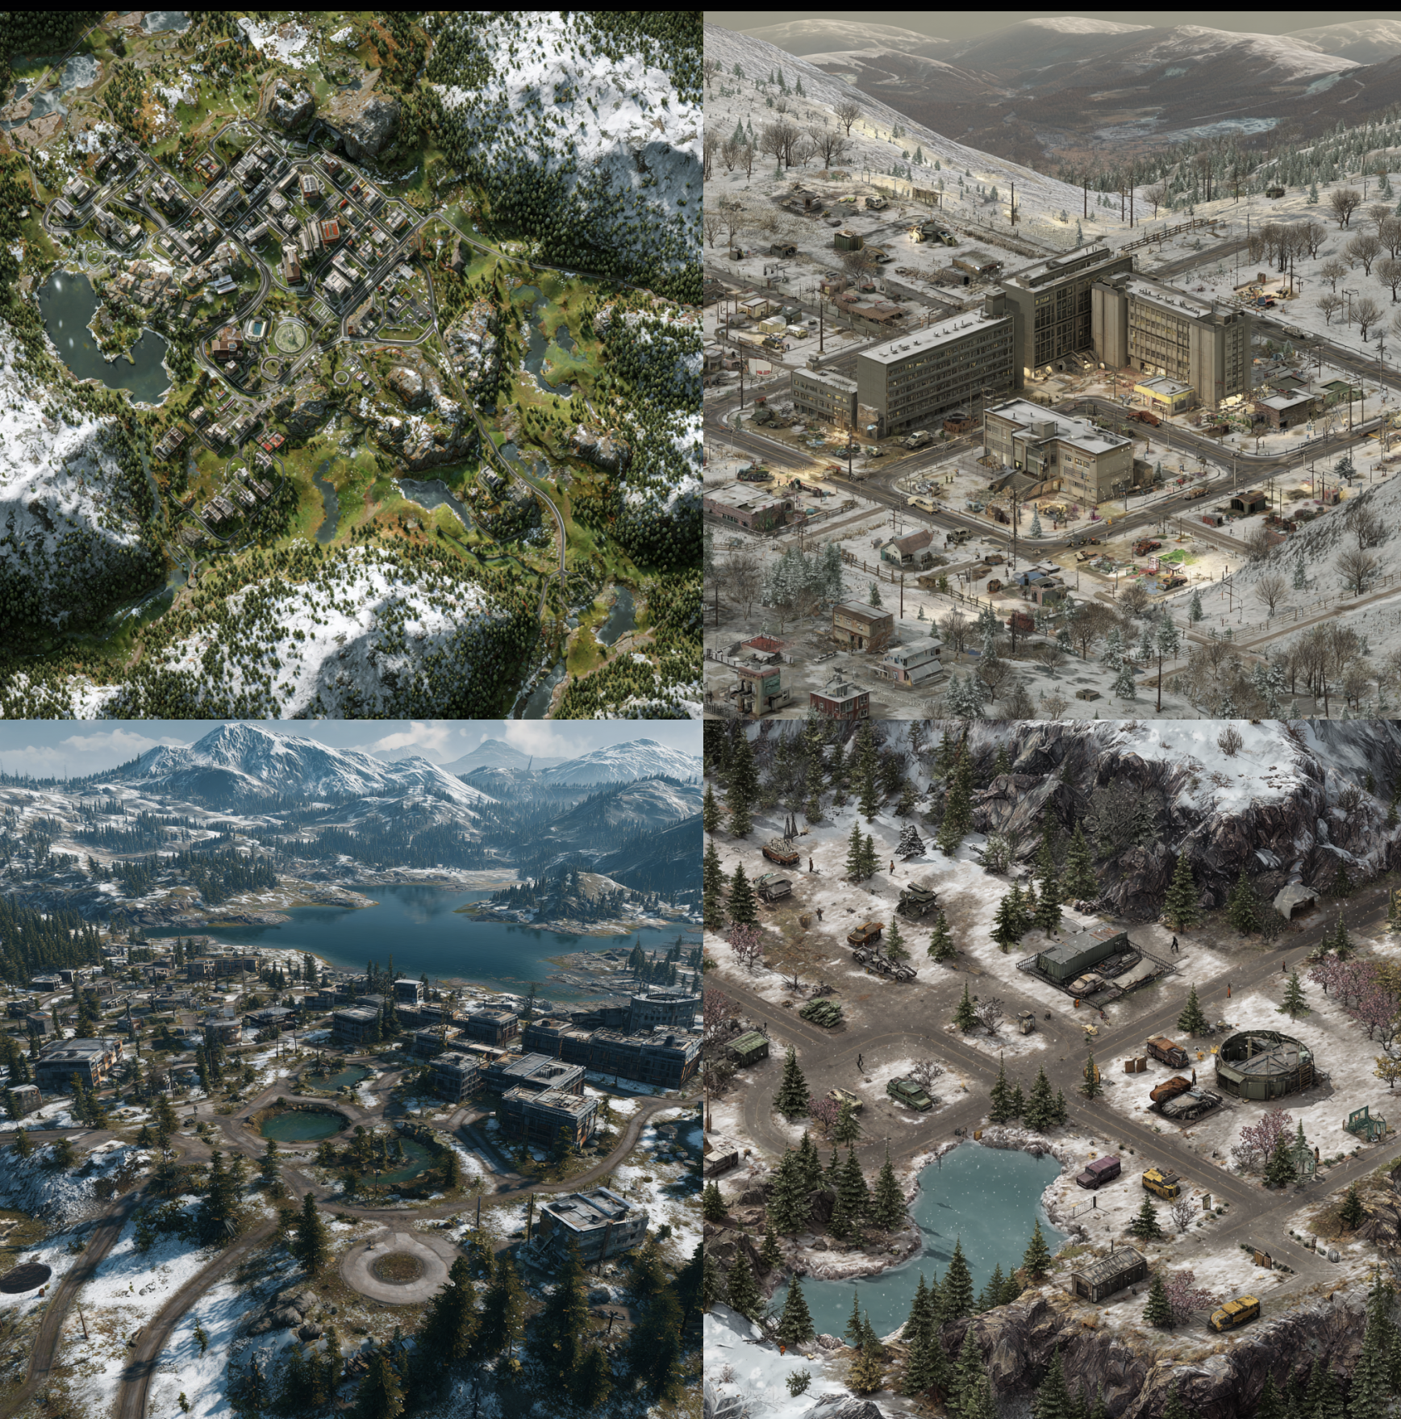

The Nomen — Architects of the End
When civilization collapsed, most people searched for safety.
Aiden Creek and Dustin Elke searched for structure.
Before the Fall, Aiden was a tour guide — a smooth talker who sold ghost tours through Million Bay’s broken ruins. Dustin was a real estate agent, the kind who could sell you a graveyard and call it waterfront property.
But when the sirens went quiet and the streets turned to smoke, the two found purpose in the wreckage: rebuilding the world as a business.

The Birth of Order
They called their creation The Nomen — “The Name.”
A symbol of order, control, and calculated evil.
In their creed, chaos was unprofessional.
Members wore tailored business suits, pressed and clean, to remind the world that even the apocalypse could be civilized — if ruled by the right men.
They created compounds where every door stayed open — a metaphor for transparency and surveillance. No secrets. No excuses. Every transaction, every conversation, every death — logged, priced, and justified.
They didn’t preach religion or mercy. They preached management.
And when someone refused to wear a suit, the Nomen fired them permanently.

The Fall of the Projects
Their first headquarters rose from the ashes of an old project housing district in southwest Million State. For a while, they ruled it like a corporation — complete with a hierarchy, payroll, and hit lists disguised as “employee terminations.”
But then came the Renegades — roaring bikes, burning rubber, and the chaos of Sunny Jean’s uprising.
Aiden and Dustin’s empire crumbled overnight.
The Renegades stormed their gates, tore through their ranks, and burned the banners that hung from their towers.
Aiden watched the empire fall. Dustin lost half his face in the explosion.
Their suits were soaked in gasoline, their followers scattered. The Nomen were no longer businessmen — they were ghosts in neckties.

The Shadows Spread
In the aftermath, Aiden and Dustin went underground — literally.
They rebuilt in secret beneath Million Bay, inside abandoned subways and hotel basements, engineering heavy artillery and urban war tech.
They became arms dealers, creating their own breed of chaos-for-hire.
But to them, it wasn’t chaos — it was business restructuring.
Every rival faction they supplied was another experiment.
Every Greaper corpse was another line item in the profit ledger.
Their motto evolved:
“Everything is transparent. Every door is open. Order is power.”
And soon, whispers spread: Anyone who didn’t wear a suit was next.

2024 — The Alliance with the General
By 2024, The Nomen’s influence was dying — scattered cells, no leadership, no control. Then came General Mosley.
A warlord with vision. A man who saw The Nomen not as a gang, but as an infrastructure.
Mosley struck a deal: Northern Million State in exchange for obedience, artillery, and organization.
Under his command, Aiden and Dustin regained their empire.
Their black suits now bore Mosley’s insignia — a scarred eye over crossed rifles.
The Nomen became the military arm of the new regime, balancing his brute force with their corporate cruelty.
The north became a machine — uniform, efficient, merciless.
Factories smoked again. Towers lit up in the darkness.
And for the first time since the Fall, business was booming.

The Professional Apocalypse
Now, when you see men in suits walking through the ruins of Million Bay, don’t wave. Don’t speak.
Those are Nomen agents, and they’re not there to negotiate.
They say the apocalypse ended when fire hit the sky.
But in truth, it ended when Aiden Creek put on his tie, shook Mosley’s hand, and brought the business of death back to life.
Because in Million State, the Nomen don’t just survive the end of the world — they invoice it.

